GIT BASICS

1.6 Introduction of Git & GitHub

What is a Version Control System (VCS)?
👉 Imagine you are writing your Project Report.
- Day 1: You save it as report.docx.
- Day 2: You add more content and save as report-final.docx.
- Day 3: You make changes and save as report-final2.docx.
Soon, your folder looks like this:

report.docx

report-final.docx

report-final2.docx

report-final2-new.docx
Confusing, right? Which one is the latest? Which one has the correct data?
What if you want to go back to Day 1’s version?
Version Control System (like Git) solves this problem!
- Git keeps track of every change (like a time machine).
- You can go back to any previous version easily.
- You don’t need to create multiple final-final.docx files anymore!
Definition:
A Version Control System (VCS) is a tool that records changes to files over time so that you can recall specific versions later.

🔹 What is Git?
Think of Git as a CCTV Camera for your code.
- It watches every change (who did it, when, what was changed).
- It stores snapshots (commits) of your project.
- You can rewind and see the history.
- Multiple developers can work together and Git will track “who changed what”.
🔹 In technical words:
Git is a distributed version control system. It runs on your local machine and manages code versions, branches, and merging.
- Git = Version Control System (VCS).
- Tracks project changes → allows rollback.
- Enables collaboration among developers.

🔹 What is GitHub?
If Git is your CCTV camera at home, then GitHub is your cloud storage (like Google Drive) where you upload those CCTV recordings.

- GitHub is an online platform where you can store your Git repositories.
- A cloud-based platform hosting Git repositories.
- It helps you share code with teammates, manage collaboration, and contribute to open-source.
- Provides features like:
  - Pull requests (suggesting changes)
  - Issues (tracking bugs/tasks)
  - Forks (copy of someone else’s repo)
  - Branches (parallel development)
- Think of Git as your notebook and GitHub as Google Drive for your notebook.
- Git vs GitHub – Relation & Difference
Git | GitHub
Tool to track changes (VCS). | Platform to host Git repositories.
Works on your local system. | Works online (cloud).
Can be used alone (without GitHub). | Cannot work without Git.
Example: Track project locally. | Example: Share project with your team worldwide.

- Git = Notebook (where you write your code & track changes).
- GitHub = Library (where you store your notebook so that others can read, borrow, or contribute).

Why Use Both Git & GitHub Together?
- Git alone → You can track changes locally, but can’t collaborate easily.
- GitHub alone → It’s just a website, can’t track versions without Git.
- Together → You get version control + cloud hosting + collaboration tools.
Example:
Imagine you and your friends are building a mini web project:
- On your laptop, Git tracks your changes (like saving checkpoints).
- You push it to GitHub → your friends can see and pull updates.
- They add new features → push again → you pull back.
- GitHub acts as a shared code hub, Git acts as the history manager.

1.7 Installation & Configuration of Git Account

Steps:
- Download: https://git-scm.com/downloads
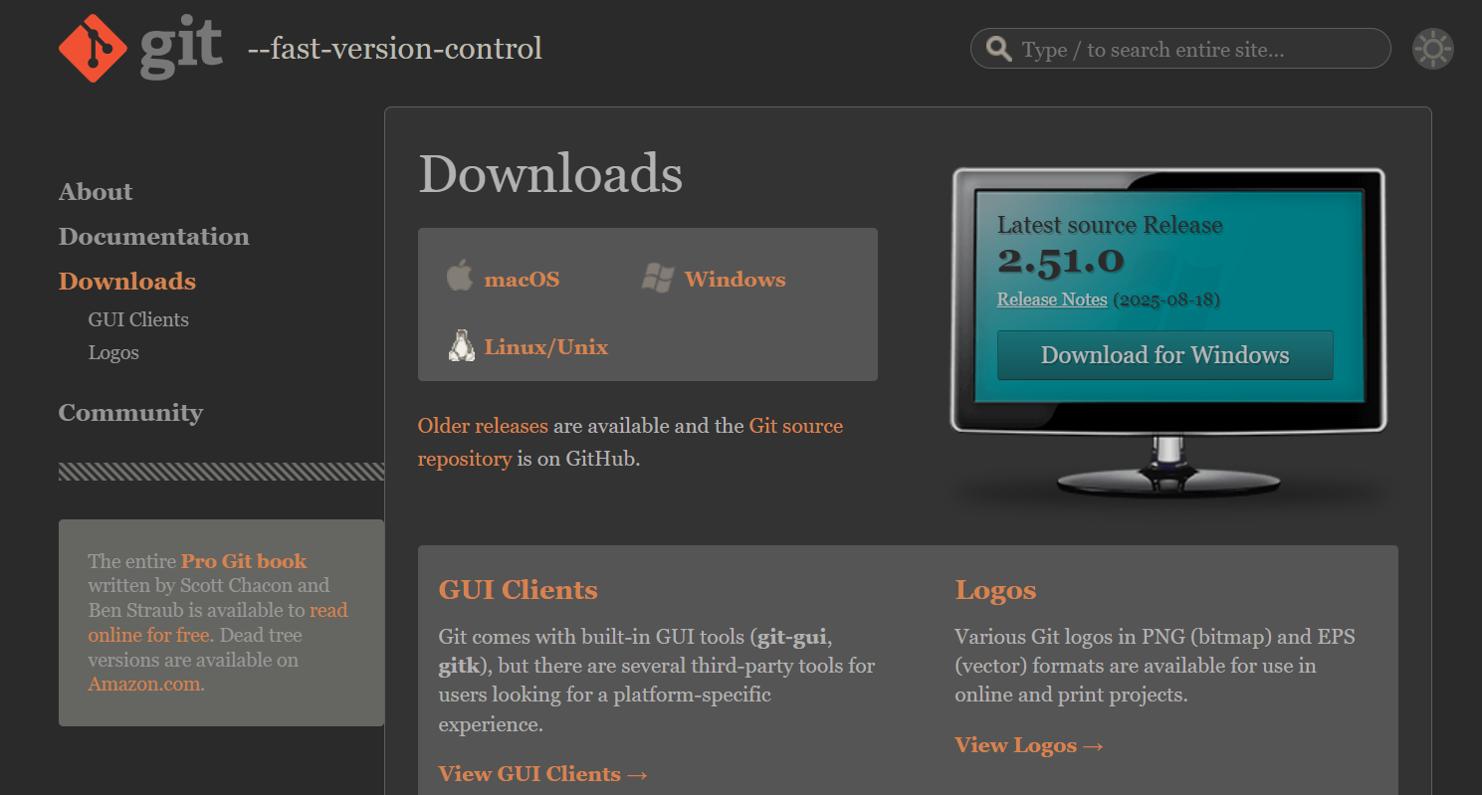
- Install with default settings.
- Open terminal/Git Bash (CMD/VS Code terminal) → check version:
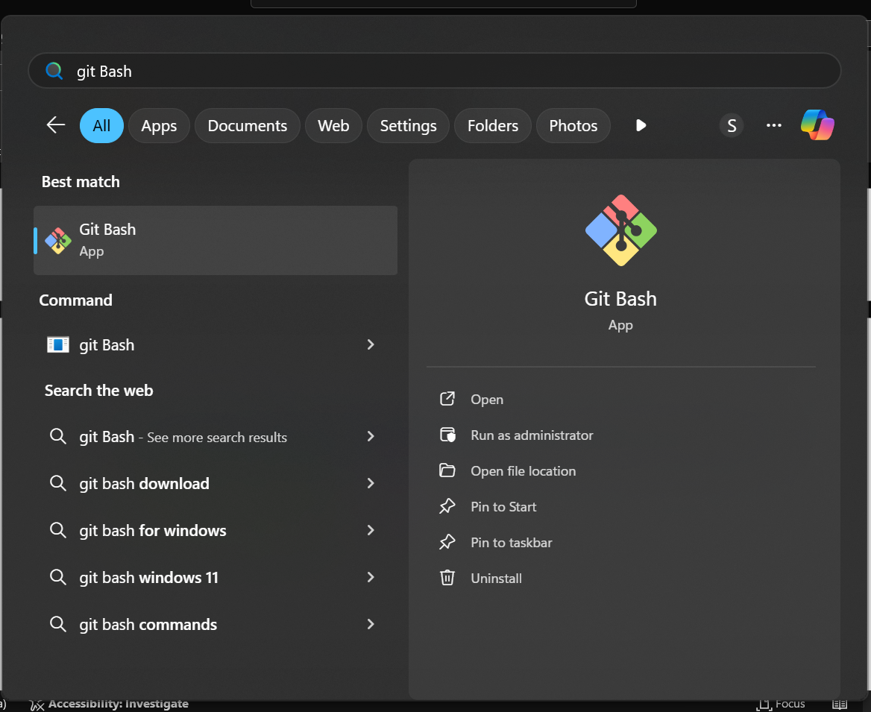
Using the command git –version
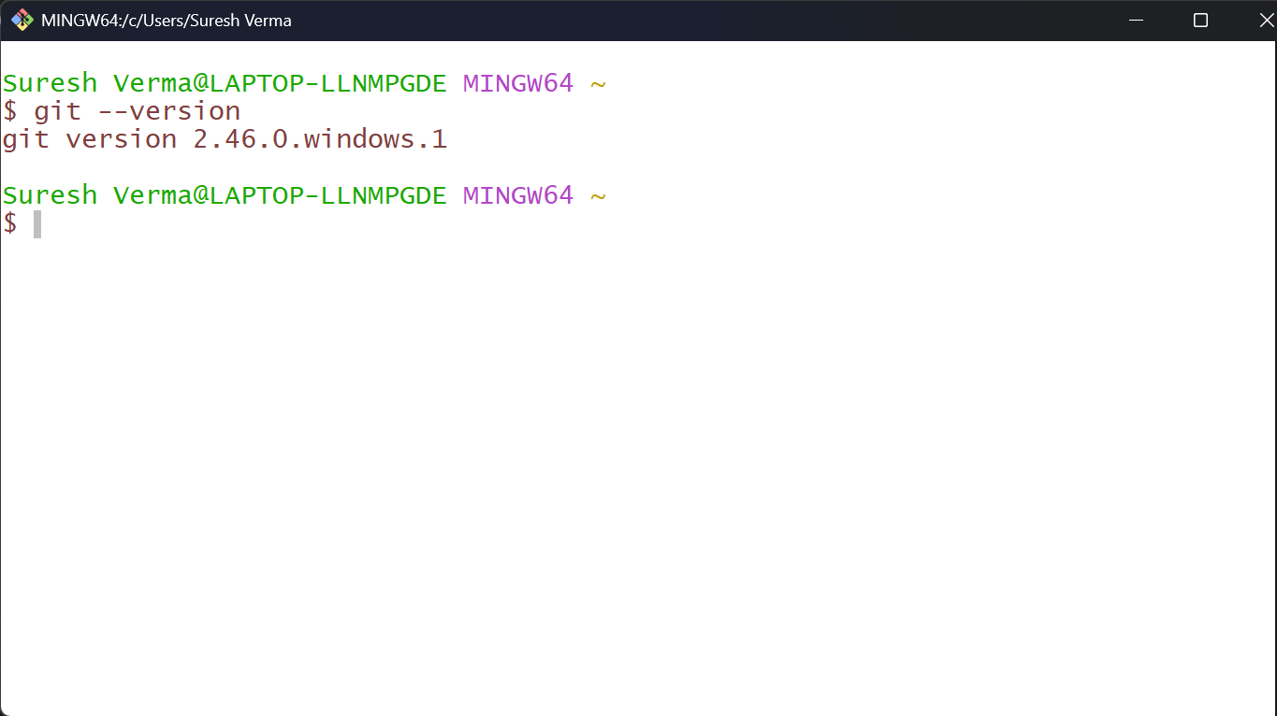

Configure Git (first-time only):
git config --global user.name "Your Name"
git config --global user.email "your_email@example.com"
git config --list # check configuration
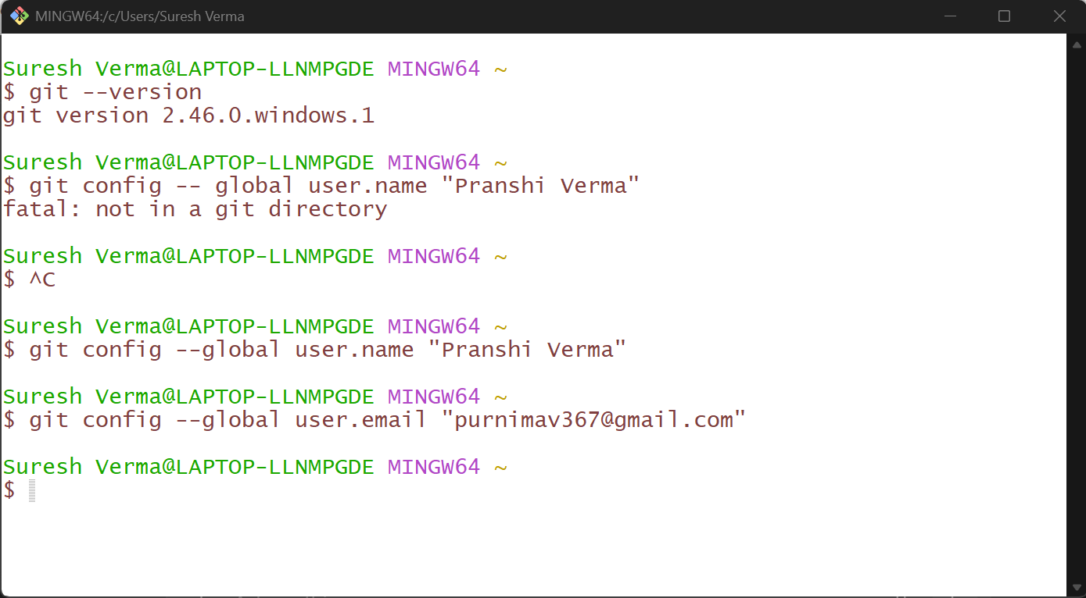

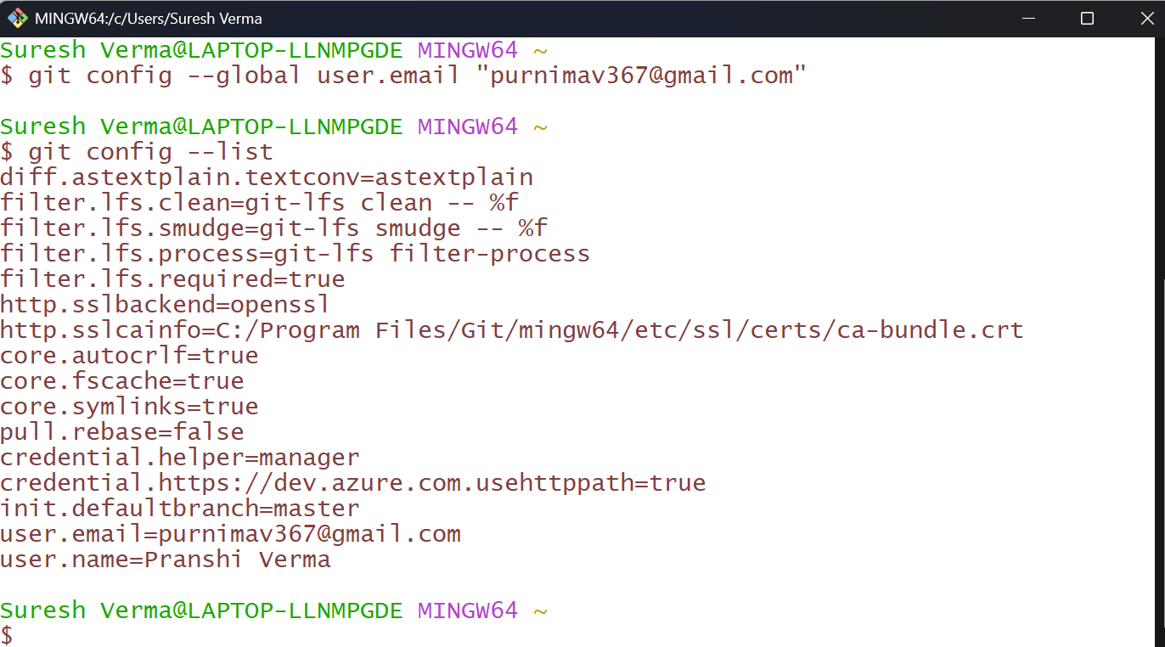

4. Creating a GitHub Account
- Go to https://github.com/

- Sign up with email → verify → choose username.
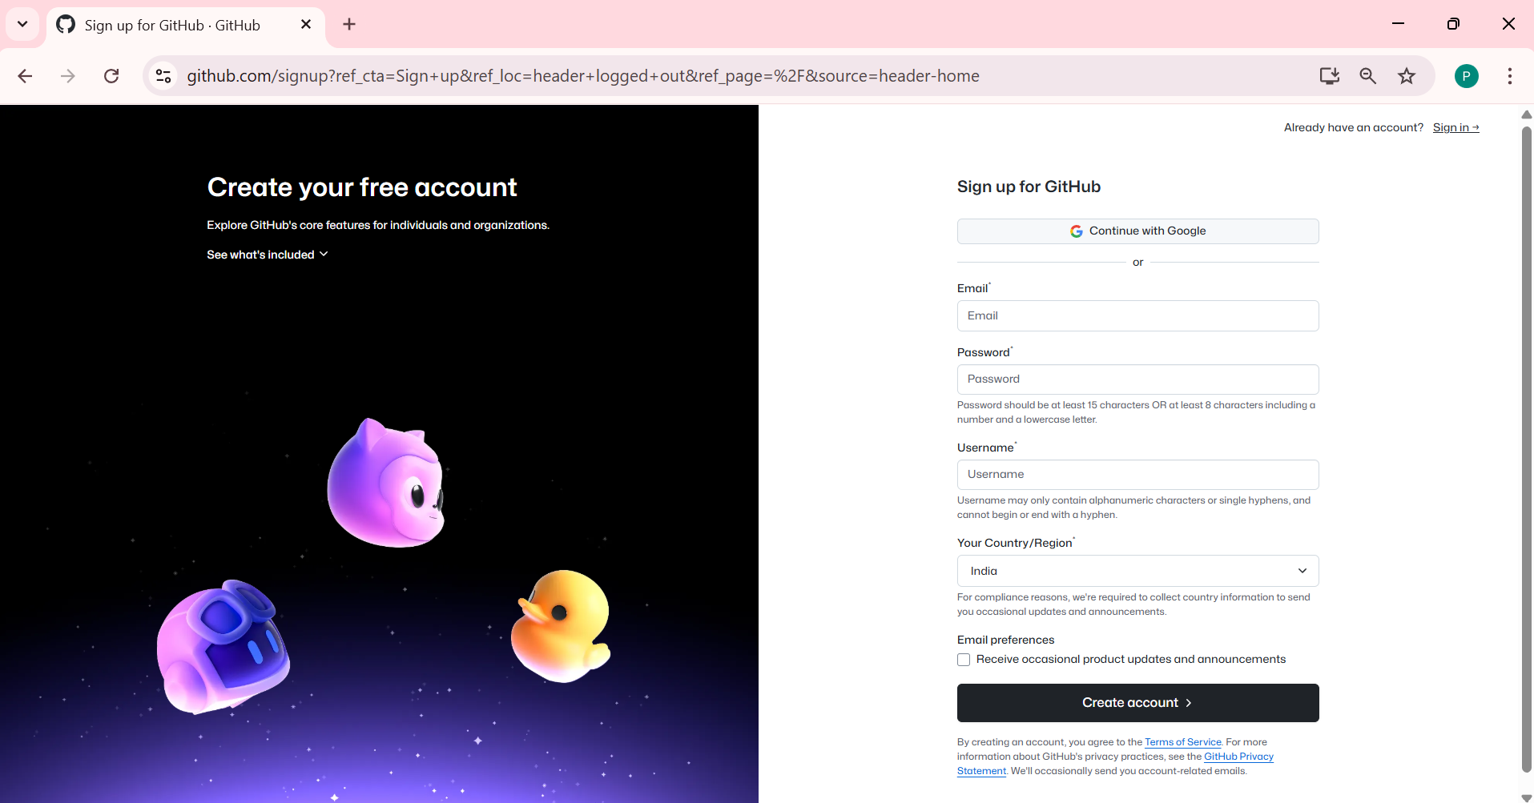
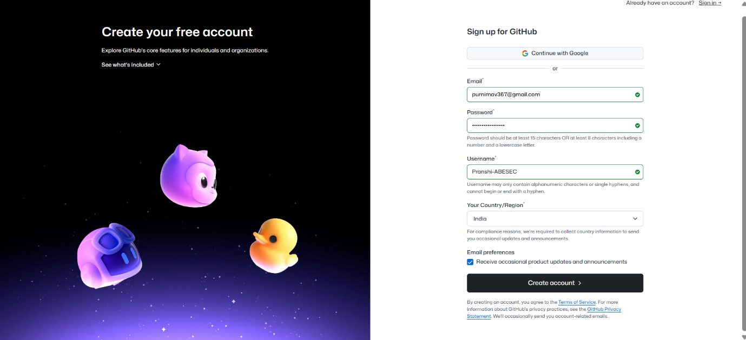
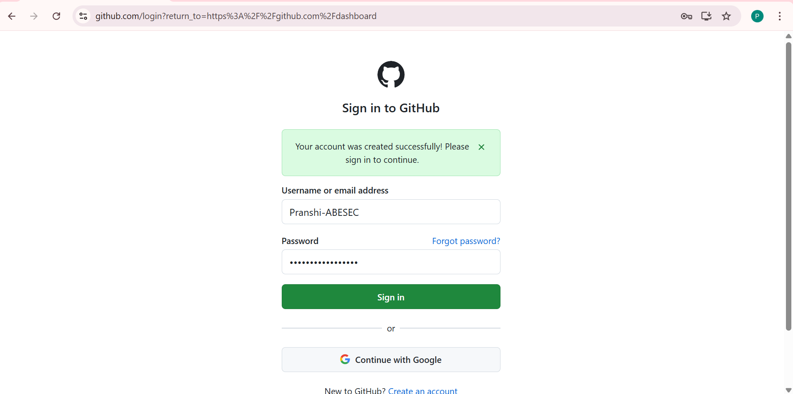
- Create a new repository:
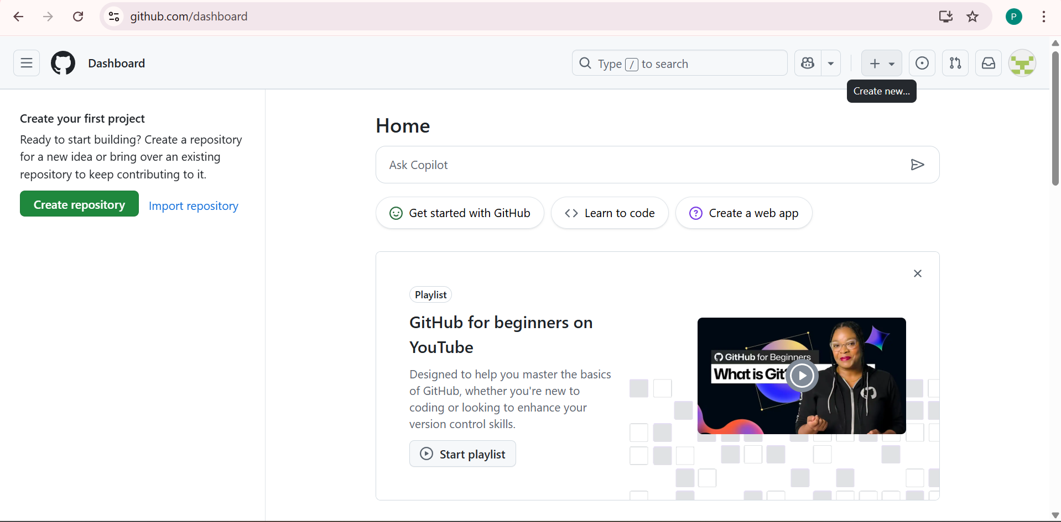
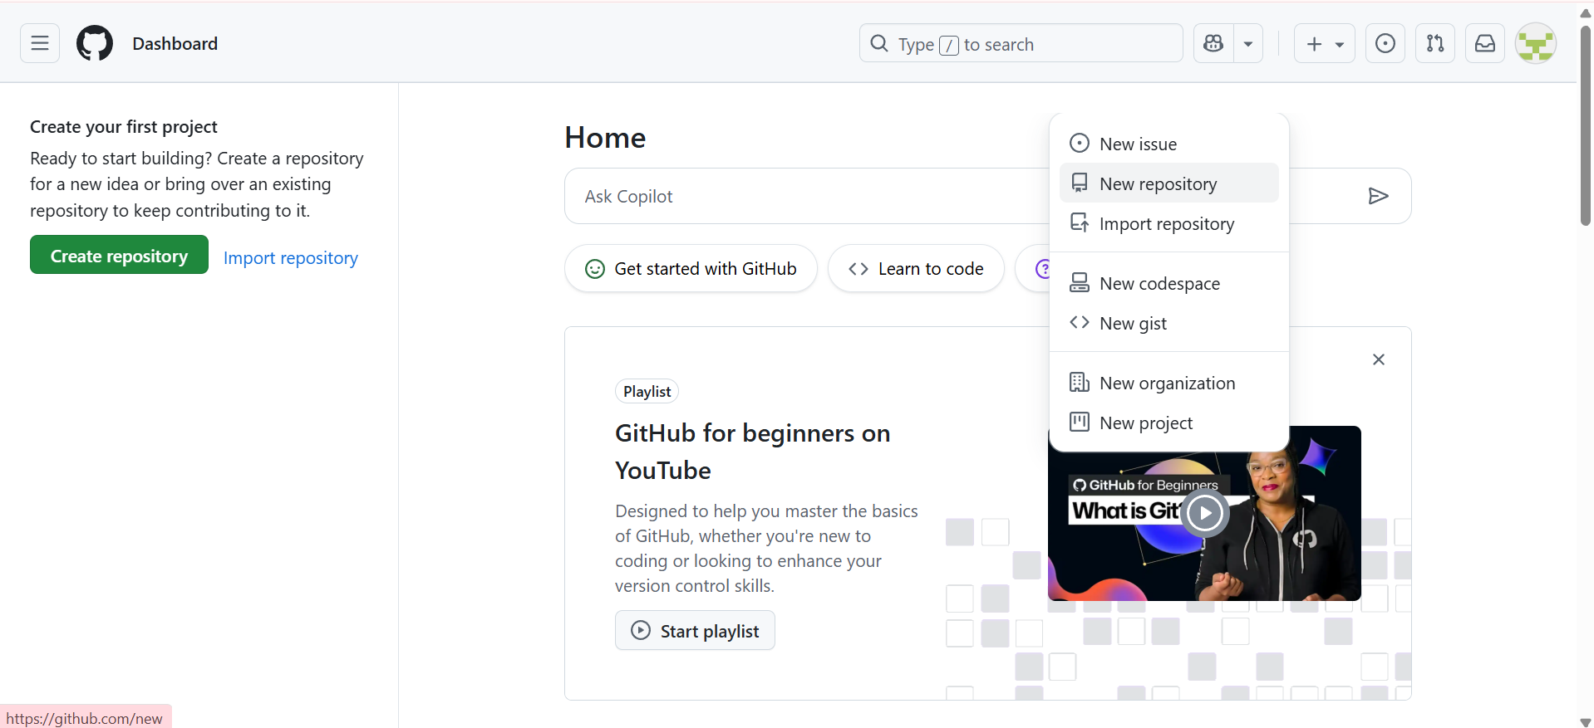
  - Repository Name: demo-web-project
  - Description: "Learning Git & GitHub"
  - Public → Add README.md → Create Repository.
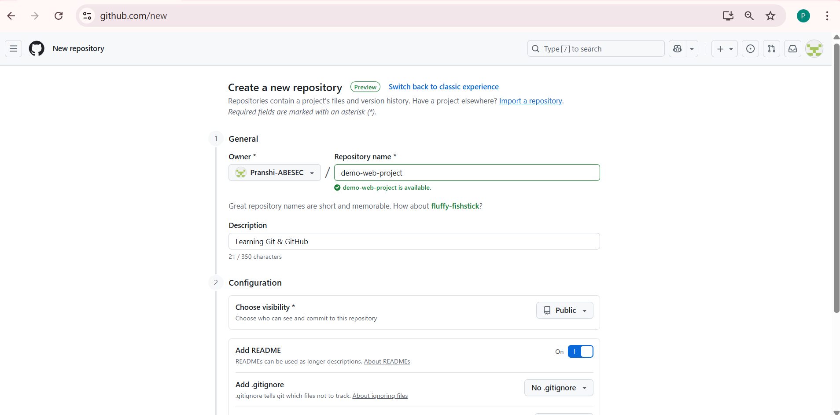
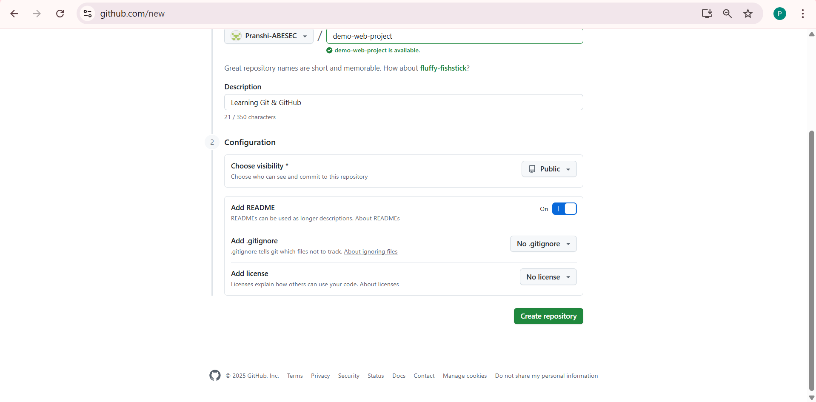

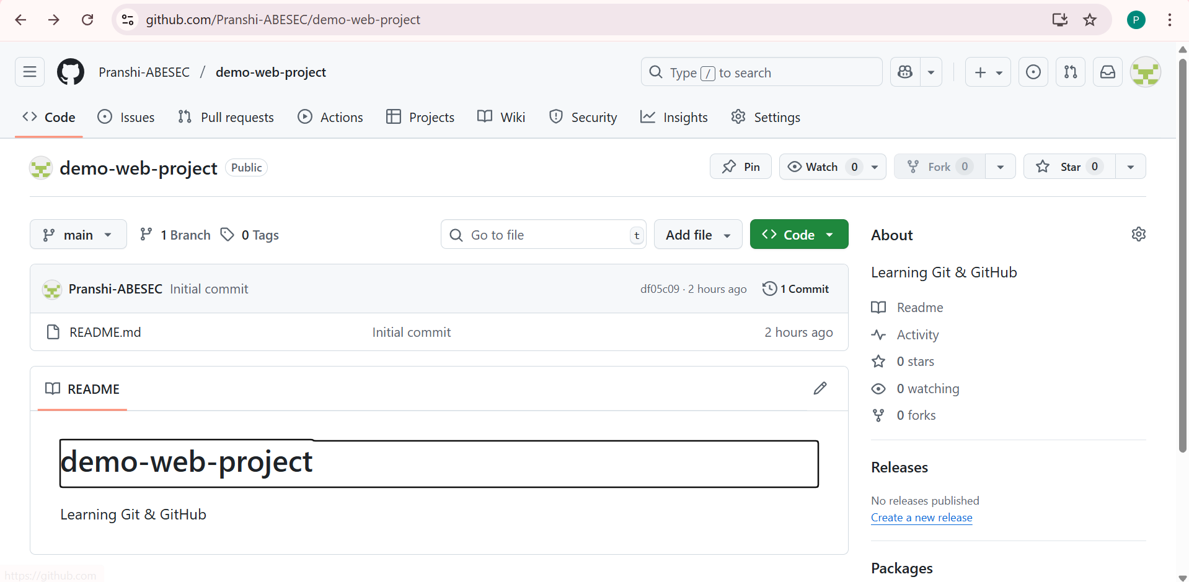

Clone the Repository
Clone the remote GitHub repository into your local system:

How to Copy the HTTPS URL of a GitHub Repository
- Open GitHub
  - Log in to your GitHub account.
  - Go to the repository you just created (e.g., demo-web-project).
- Locate the Code Button
  - On the repository page, at the top-right (just above the file list), you’ll see a green button labeled "Code".
  - Click on it.
- Select HTTPS Option
  - A dropdown will appear with three tabs: HTTPS, SSH, and GitHub CLI.
  - Make sure HTTPS is selected (default option).
- Copy the URL
  - You’ll see a link like this:
https://github.com/Pranshi-ABESEC/demo-web-project.git
- Always prefer HTTPS for beginners. Advanced users can switch to SSH for easier authentication.

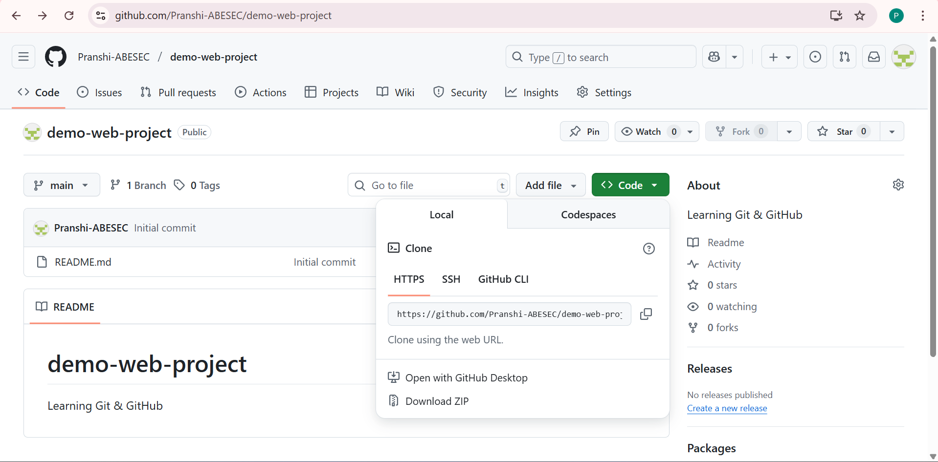
- On the right side of the link, click the Copy icon.
5. Verify the URL
- Paste the copied URL in a text editor or directly in the Git Bash command to confirm it’s correct.
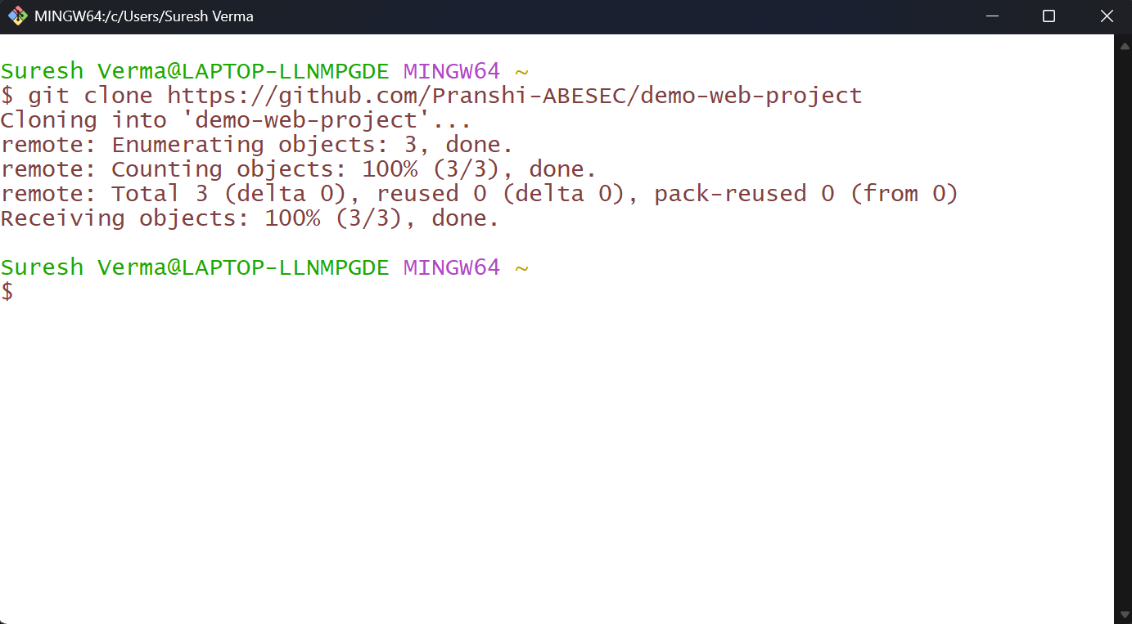
A folder will be created: demo-web-project
Move inside the folder:
Using the command cd demo-web-project
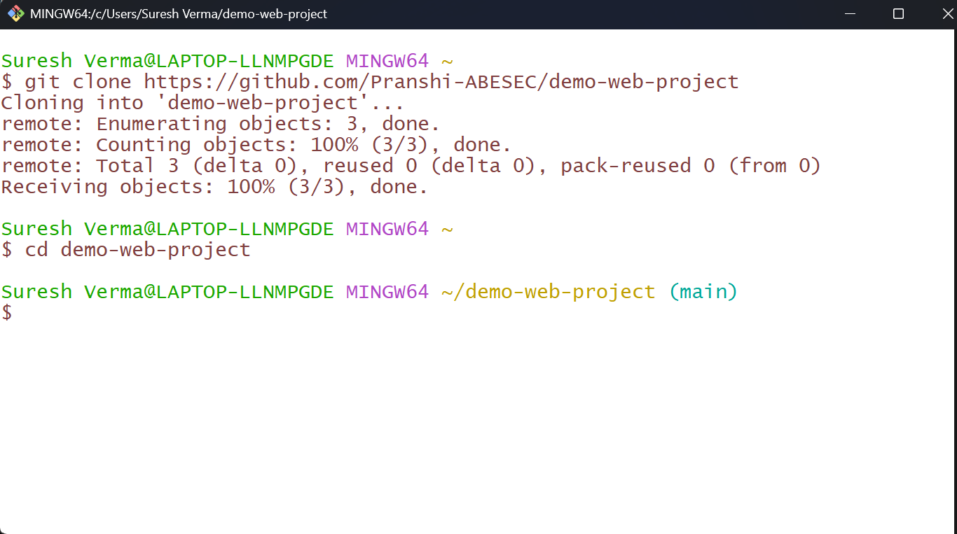
6. Create a New File (index.html)
Now, create a simple HTML file:
Using the command echo "<h1>Hello GitHub</h1>" > index.html

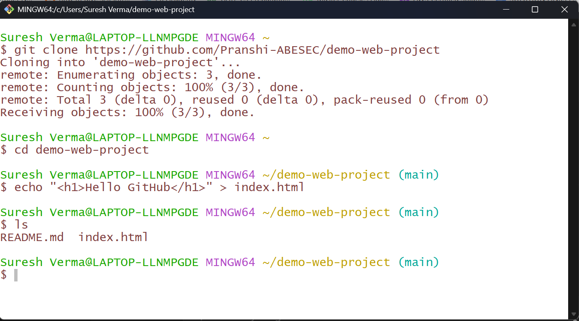
7. Check Git Status
Check the current status of the repository:
Using the command git status
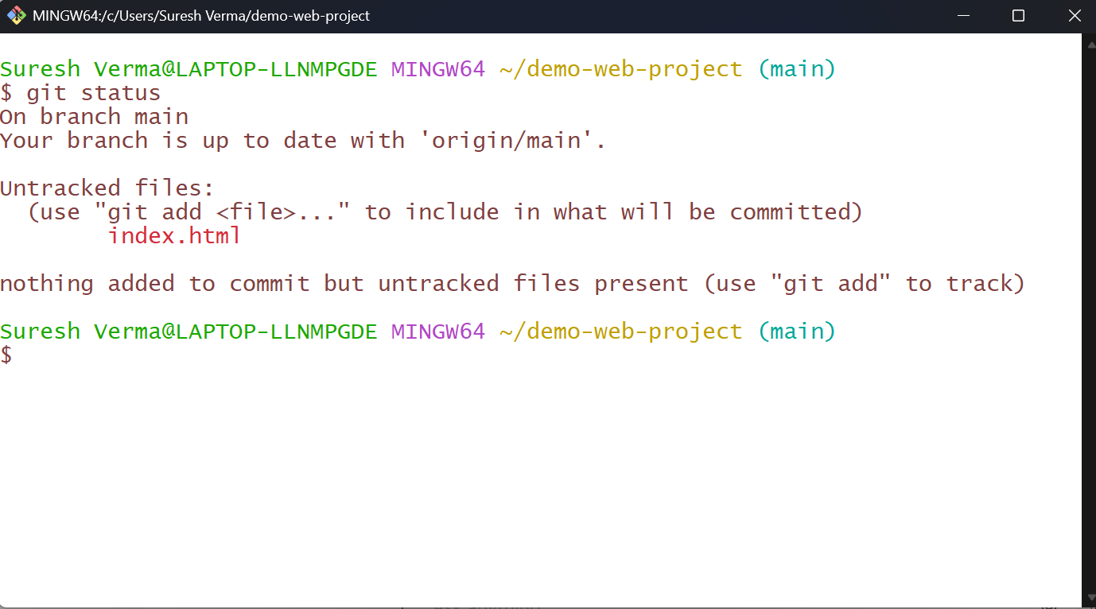
8. Stage the File
Add index.html to the staging area:
Using the command git add index.html
Check the status again:
Using the command git status
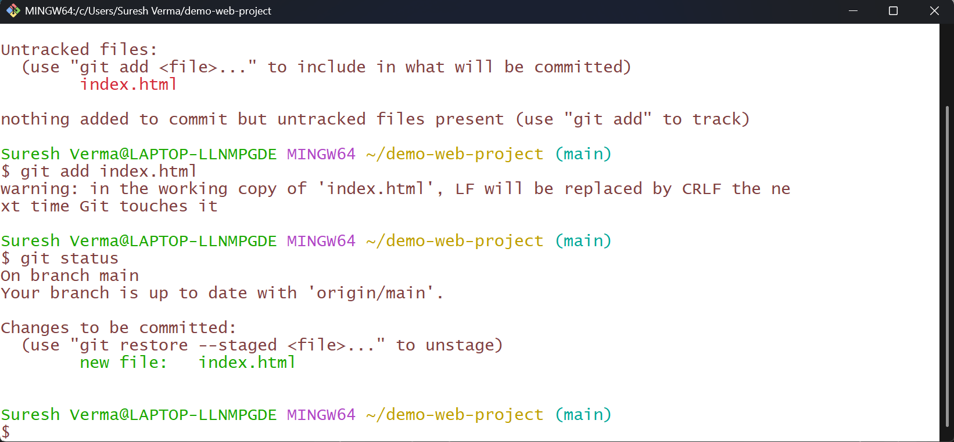

9. Commit the File
Commit the staged file with a meaningful message:
Using the command git commit -m "Added index.html file"
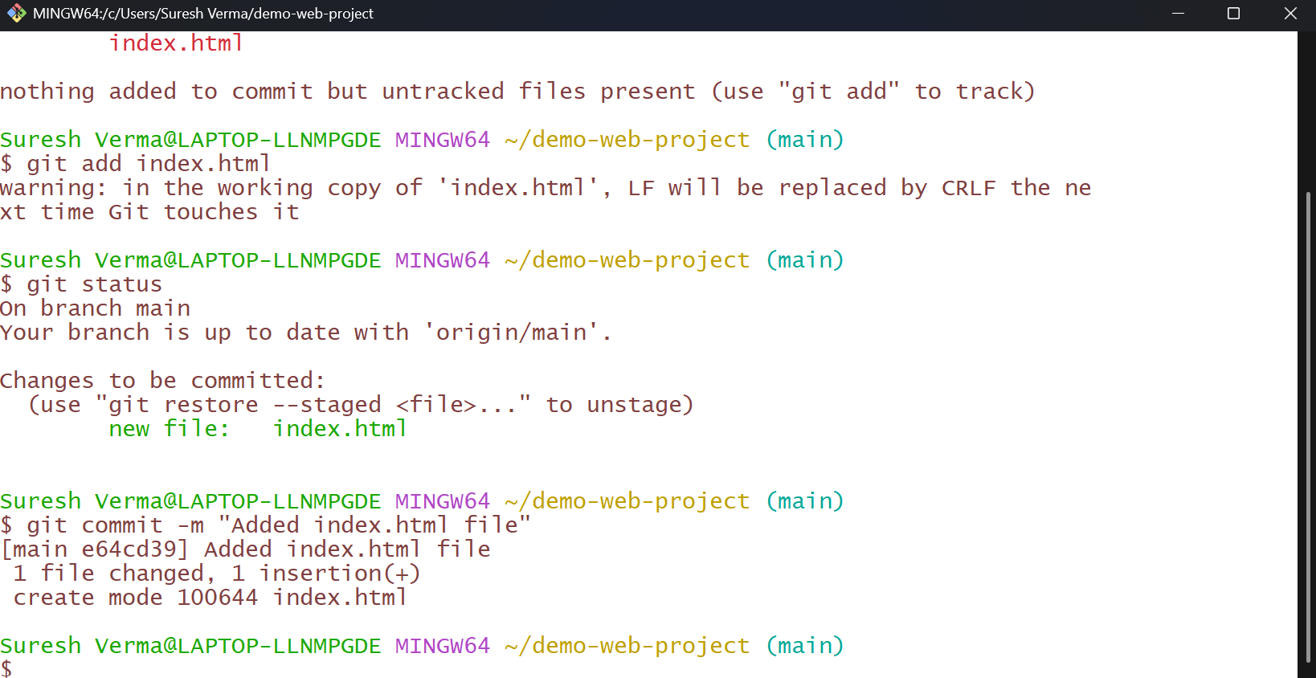
- Always use clear commit messages (e.g., ‘Added homepage file’) instead of generic ones (‘update’, ‘done’)
10. Push to Remote Repository
Push your local commit to the GitHub remote repository:
Using the command git push origin main
If this is your first push from Git Bash / VS Code, GitHub will ask you to authenticate. Follow these steps:
GitHub Sign-in Prompt
A pop-up will appear asking you to connect to GitHub.
- Click “Sign in with your browser”.
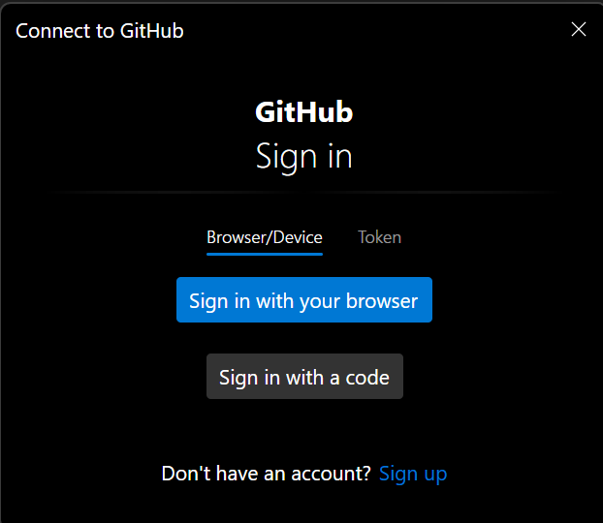
Authorize Git Credential Manager
Your browser will open an authorization page.
- Confirm your GitHub account (here Pranshi-ABESEC).
- Click “Authorize git-ecosystem” to allow access.
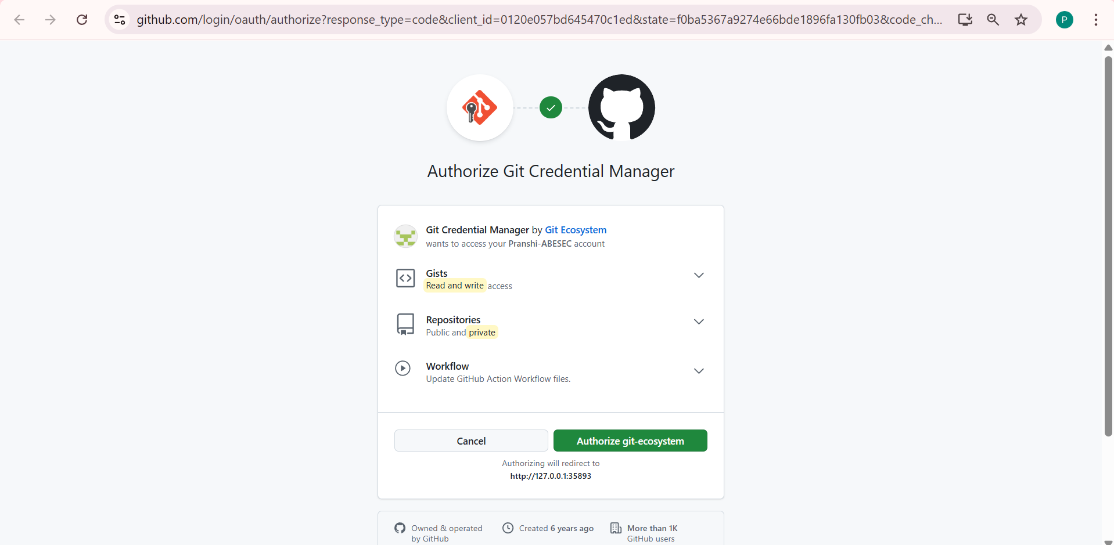
Confirm Access with Password
- Enter your GitHub password (or if 2FA is enabled, provide OTP).
- Click “Confirm”.
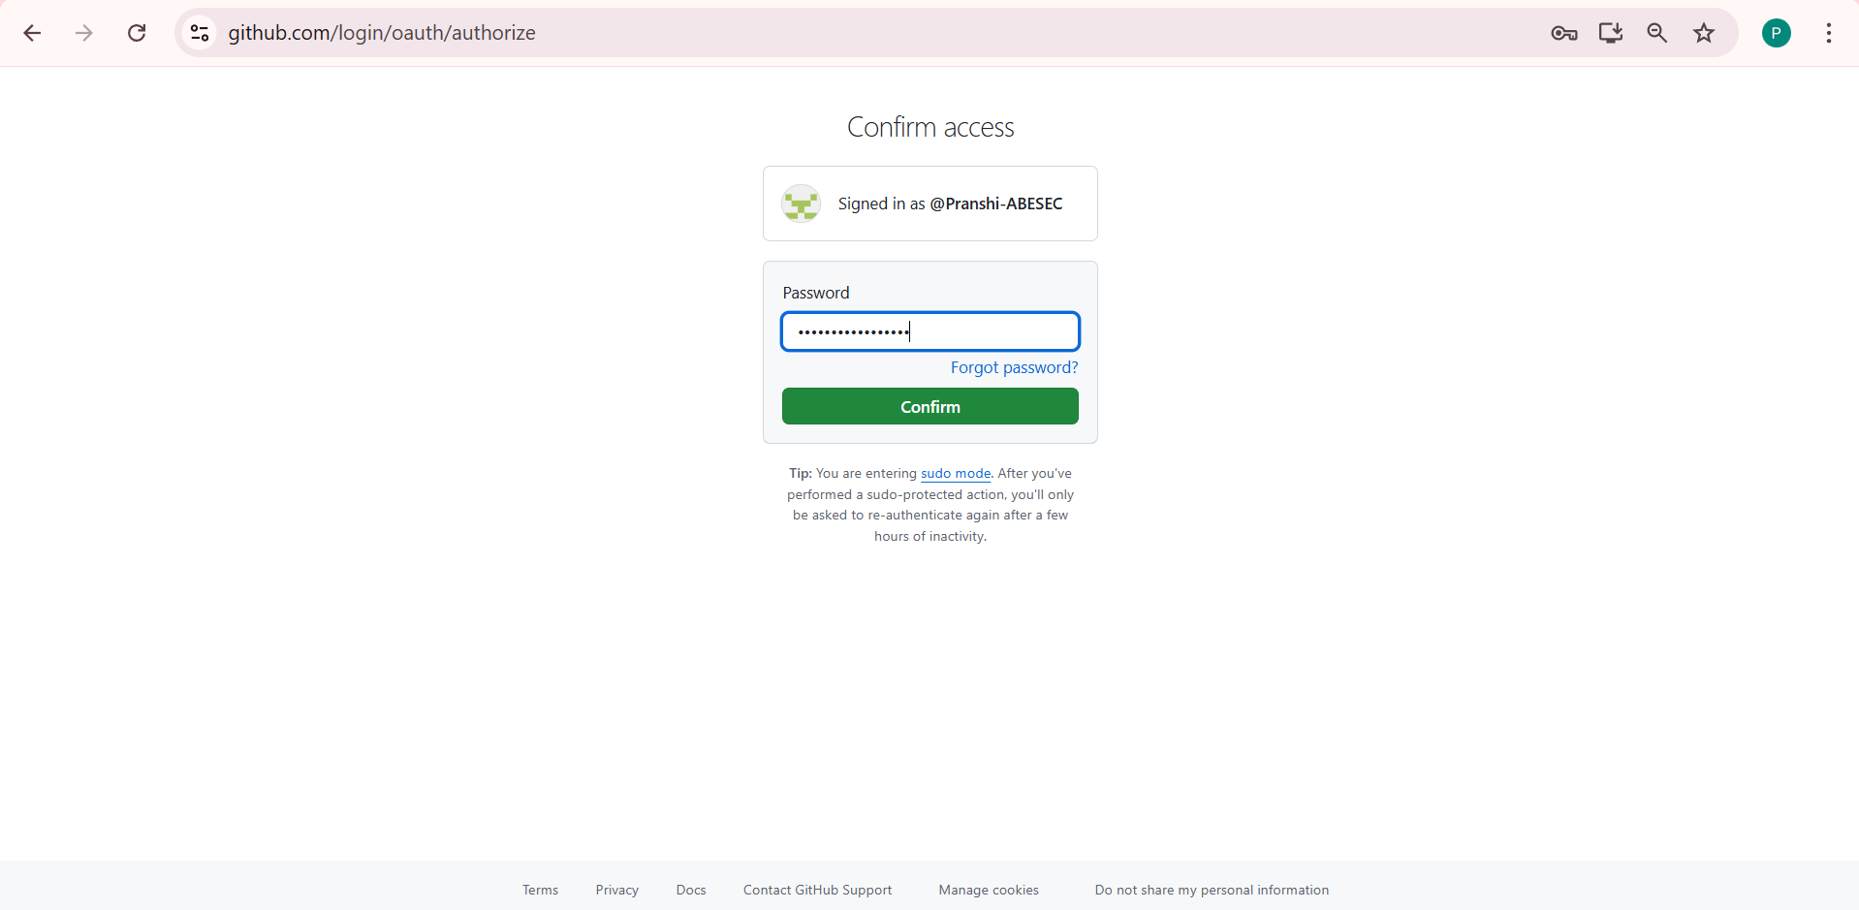
After this one-time setup, GitHub will remember your credentials using Git Credential Manager. Next time you push, you won’t need to log in again.
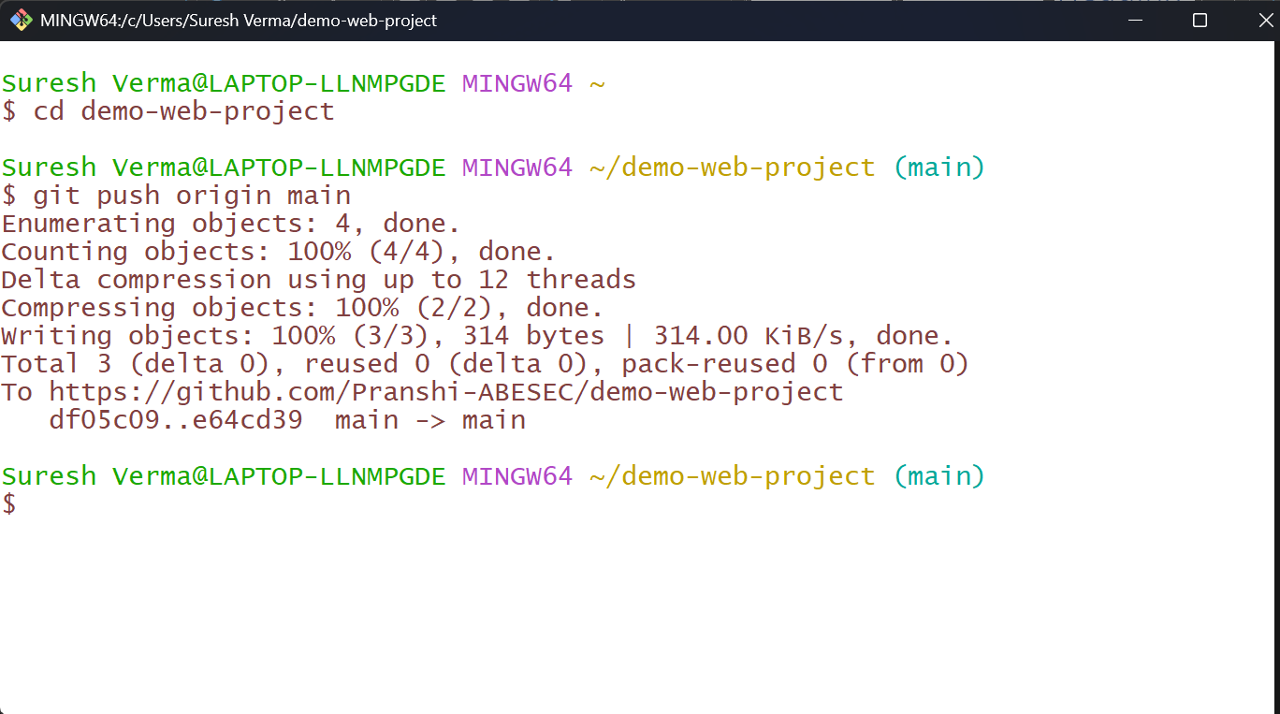
Push Completed Successfully
- The output shows that your commits have been successfully pushed to GitHub.
Right Now,
Check Git Status
Check the current status of the repository:
Using the command git status
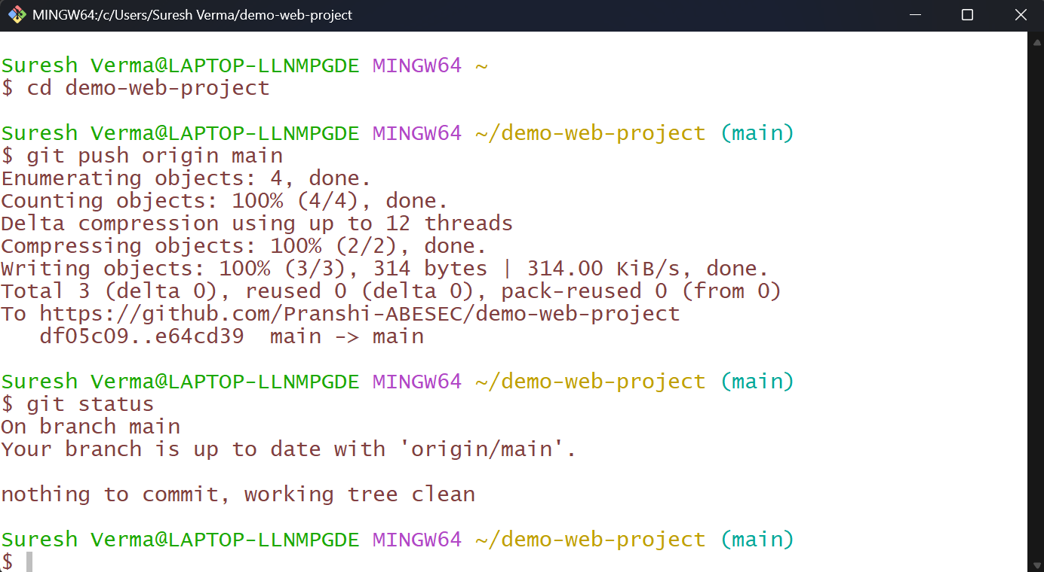
This means:
- You are on the main branch.
- Your local repository and GitHub repository are synchronized.
- No pending changes are left to commit or push.

Final Verification
Refresh the repository page on GitHub to confirm your file has been successfully pushed.

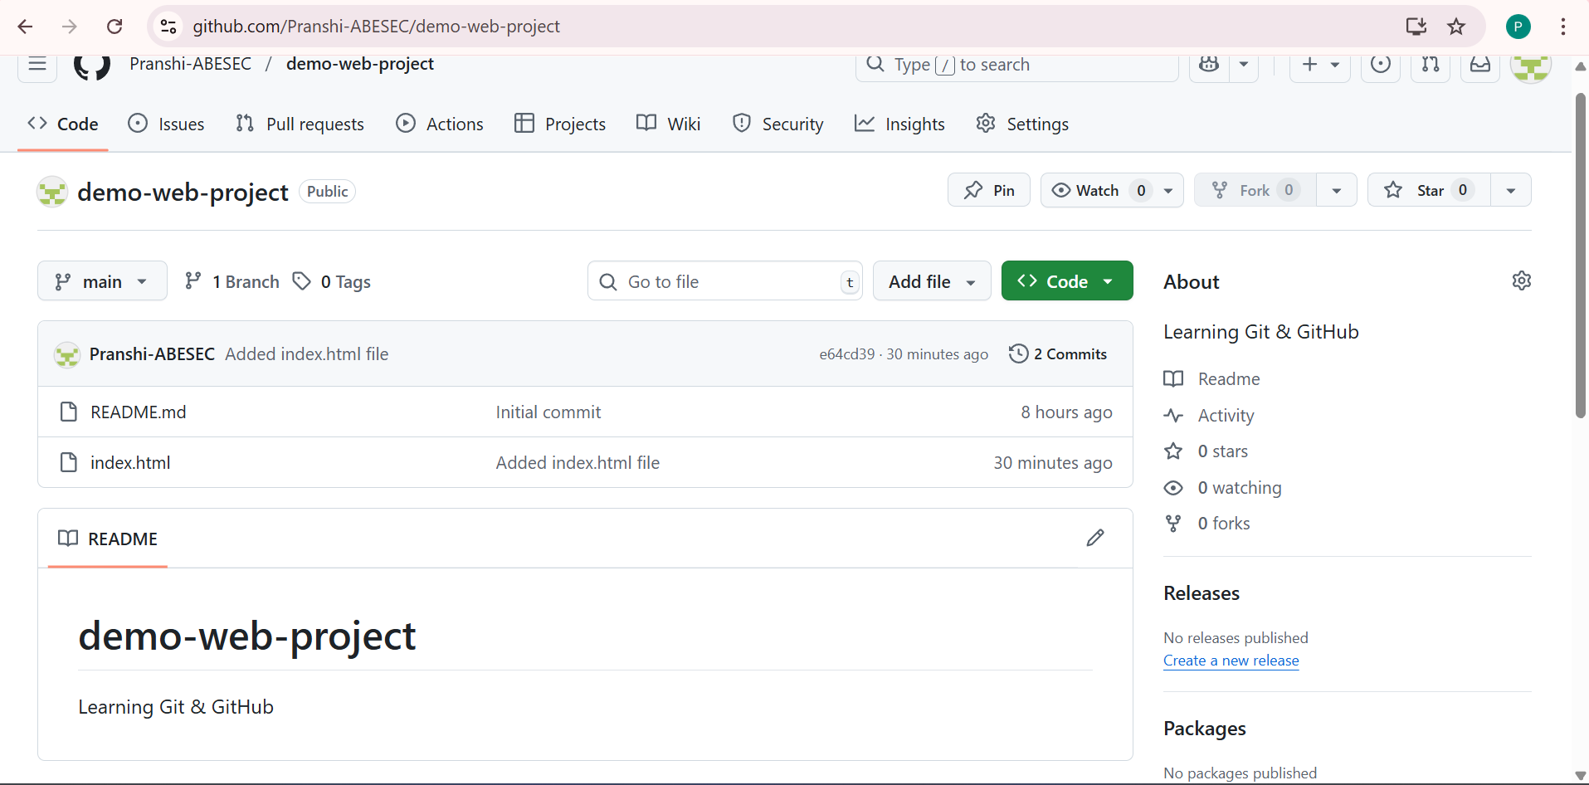

Congratulations! You have:
- Cloned a GitHub repository.
- Created your first file.
- Committed the changes.
- Pushed the code to GitHub.
Now your project is live on GitHub and ready to be shared with others.

